1. Program to perform Arithmetic operations.

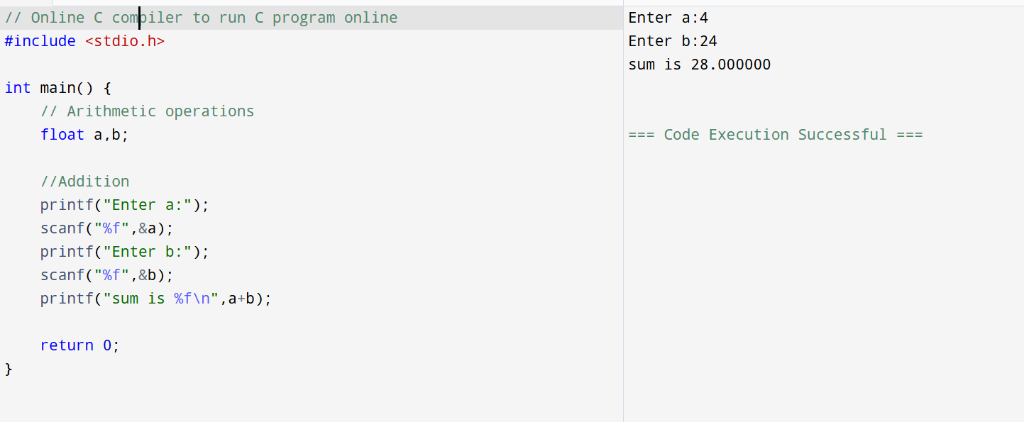

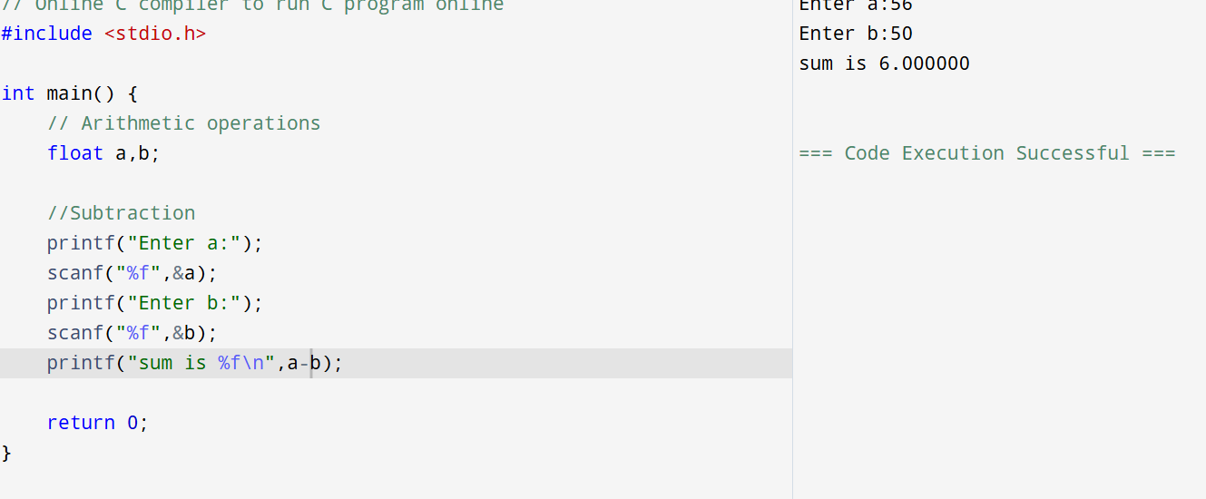

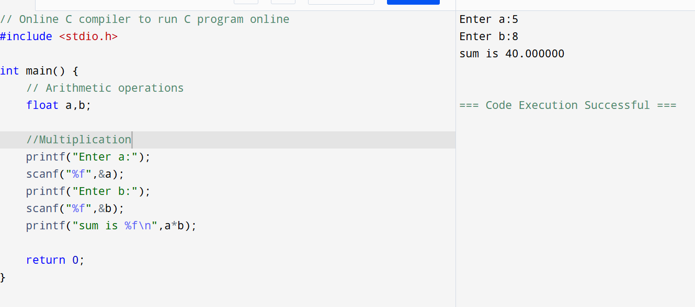

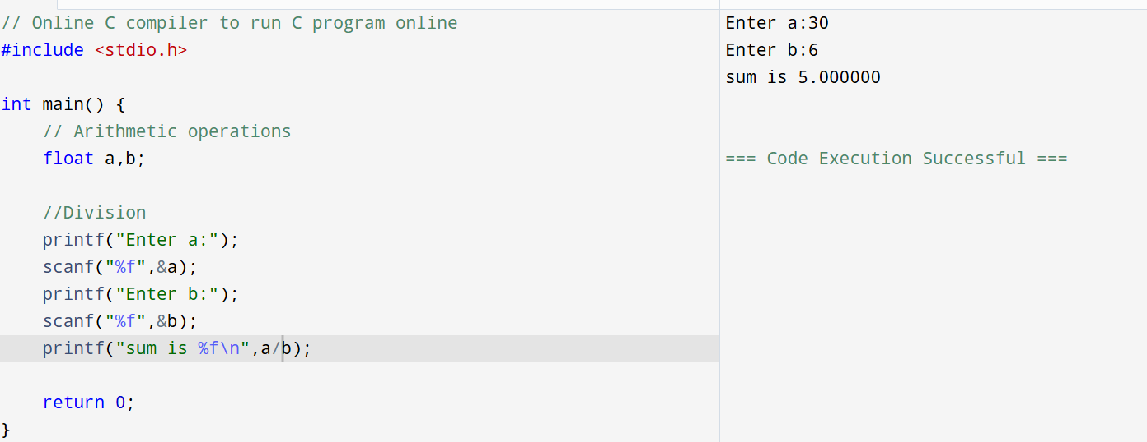

1. Program to calculate gross salary of an employee.

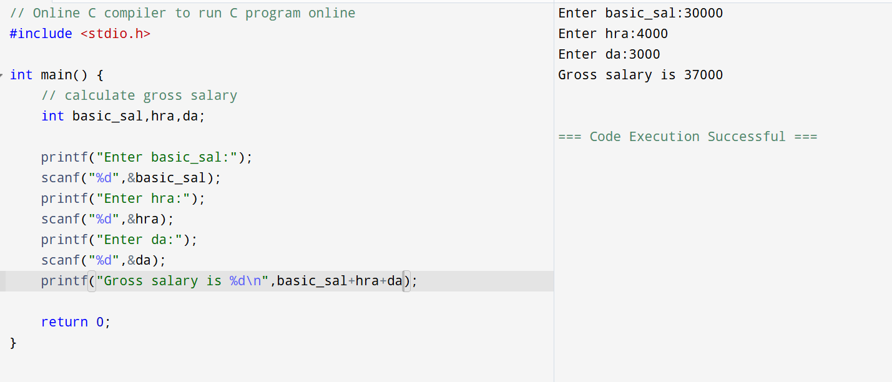

1. Program to swap two numbers without using third variables.

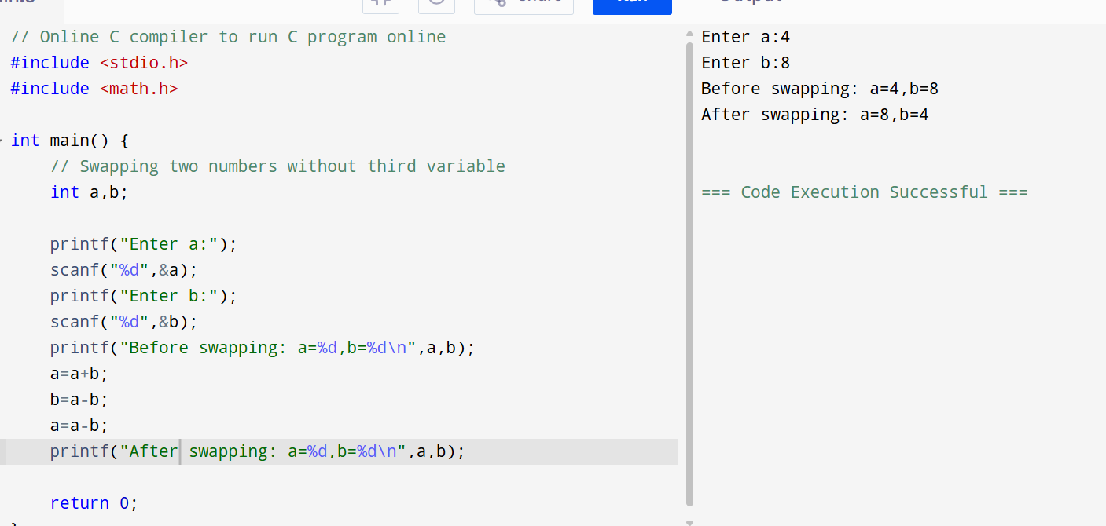

1. Program to swap two number by using temporary number.

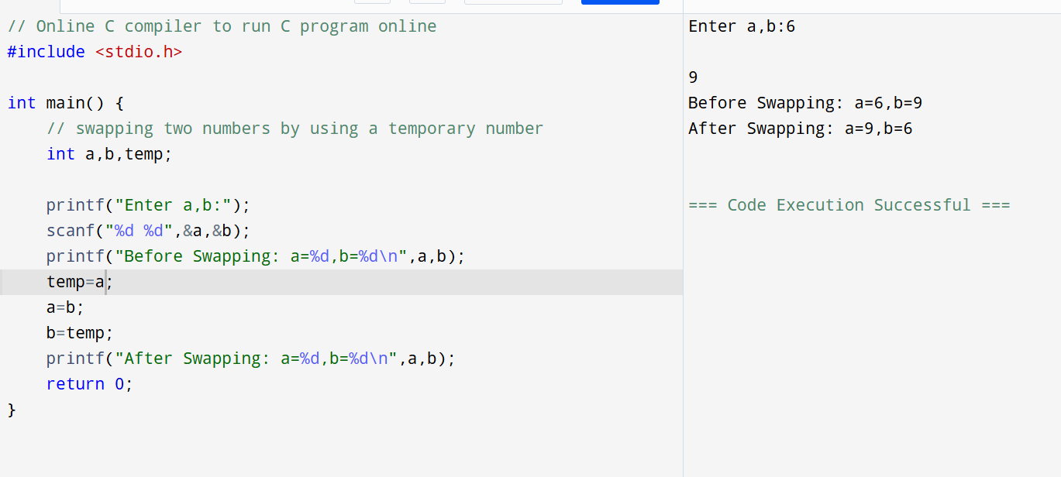

1. Program to print table of any number.

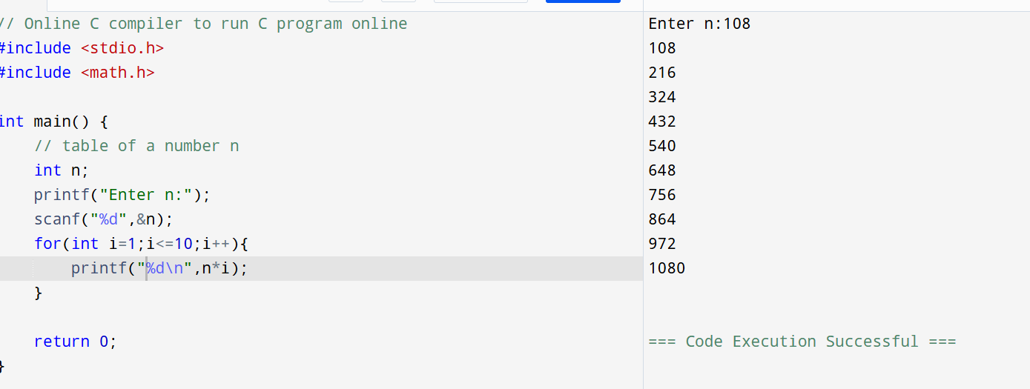

1. Program to find greatest among 3 numbers.

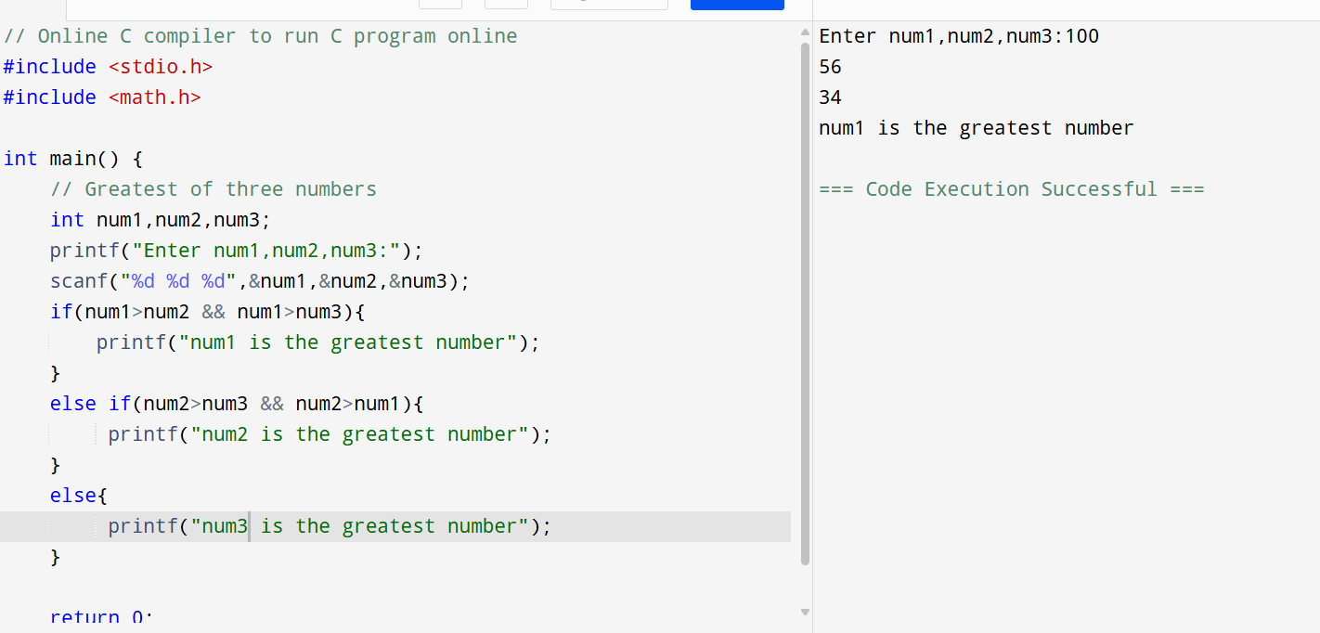

1. Program to check whether year Is leap or not.

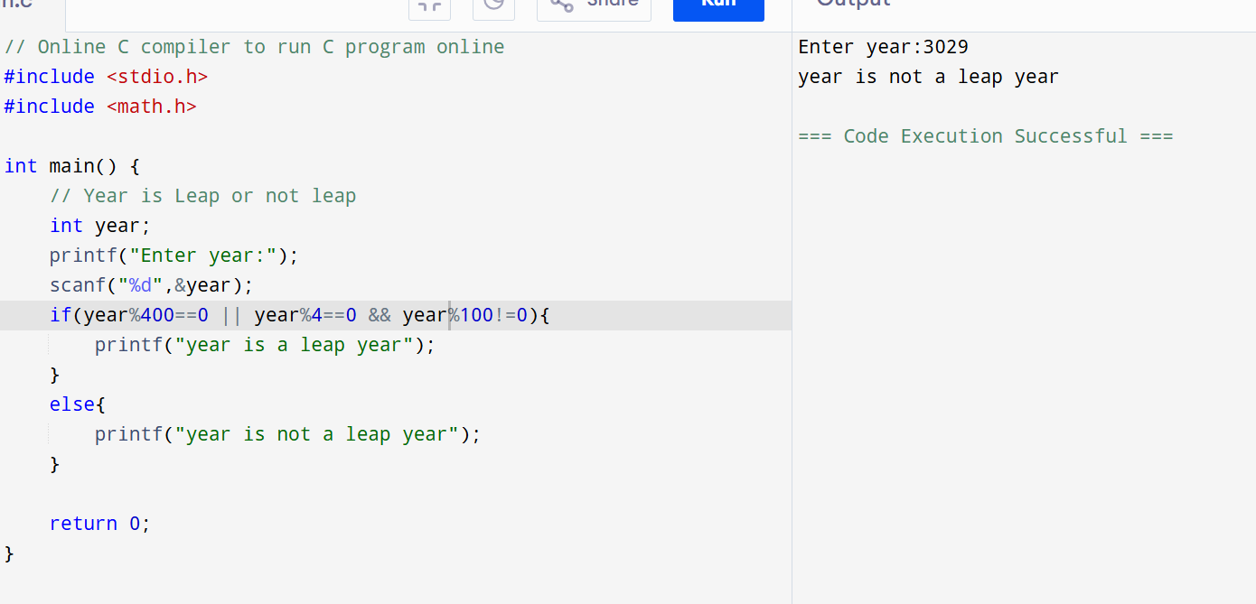

1. Program to display first 10 natural numbers and it’s sum.

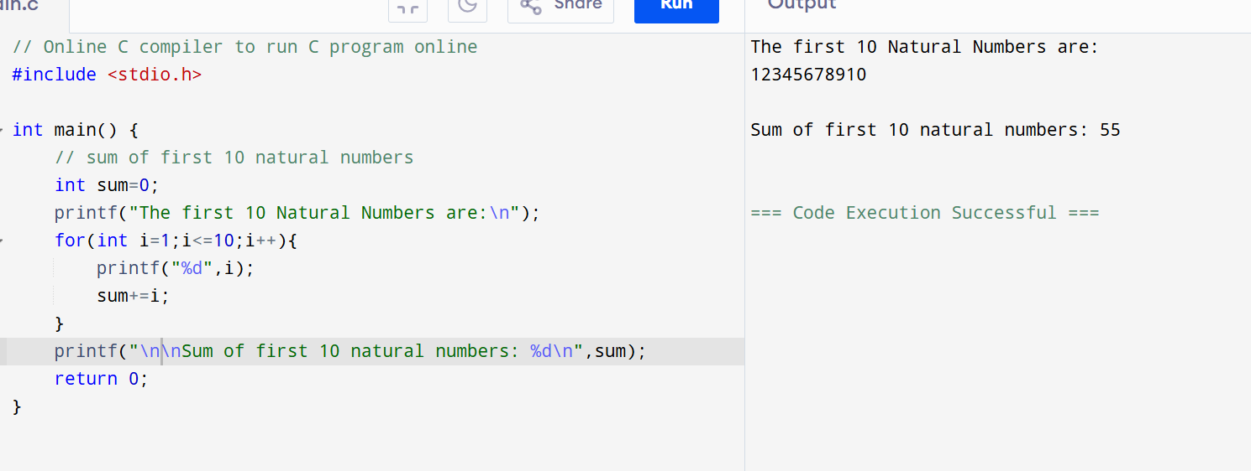

1. Program to check whether a number is even or not.

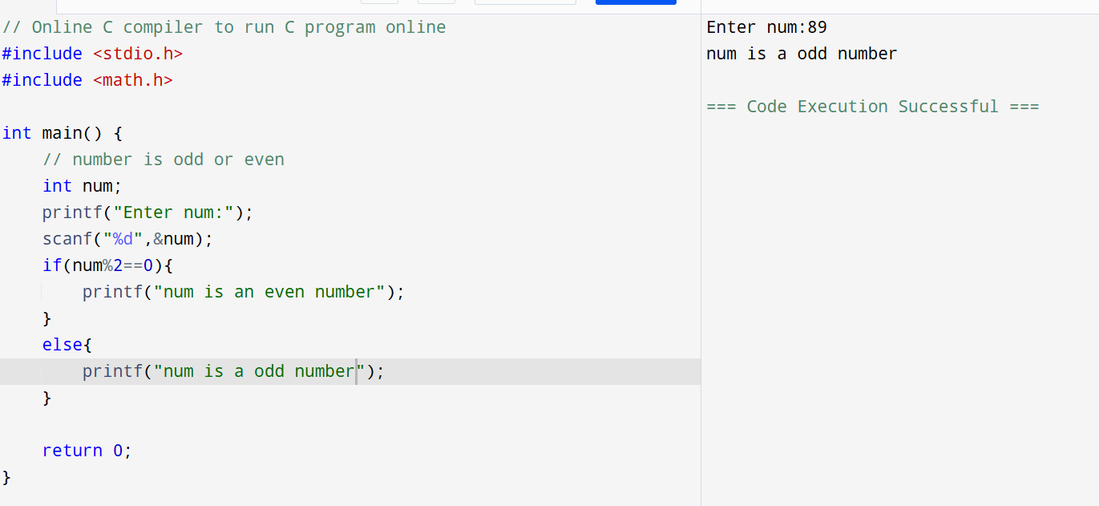

1. Program to calculate factorial of number.

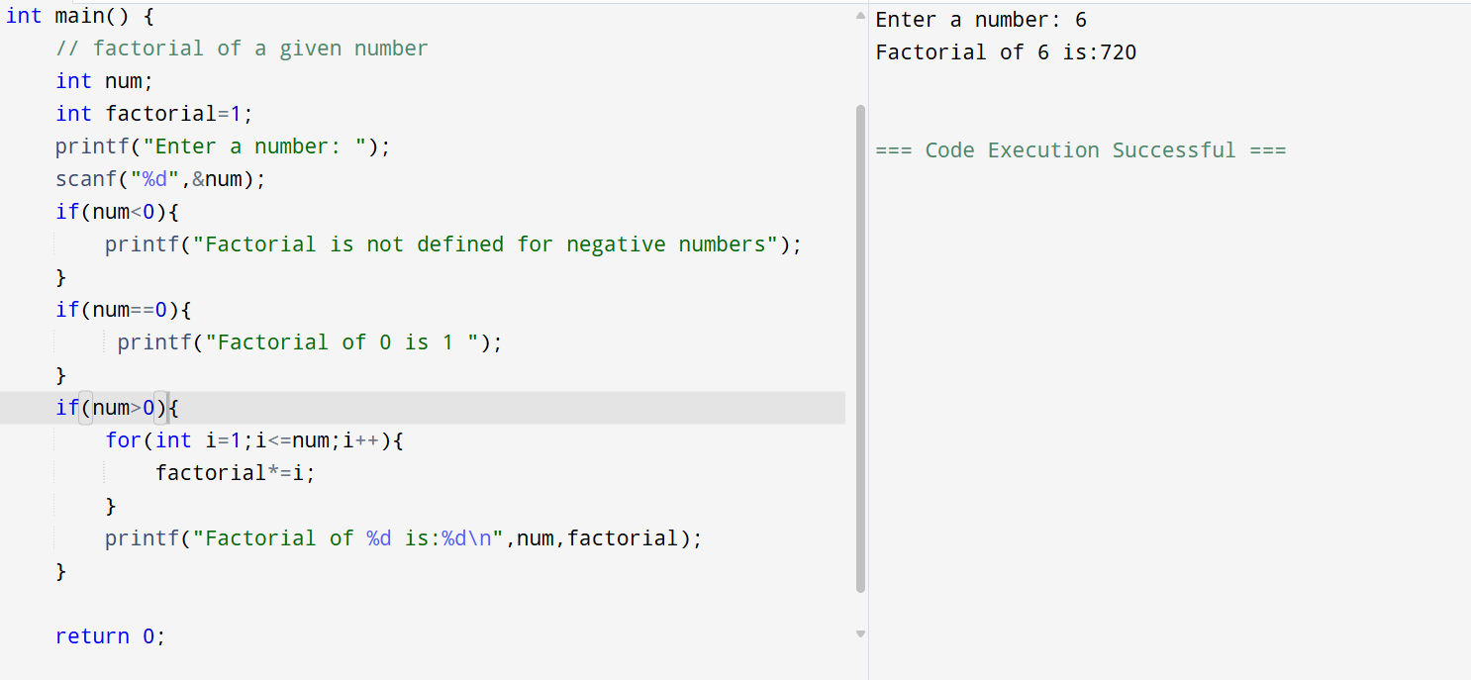

1. Program to print a pattern of stars in increasing sequence.

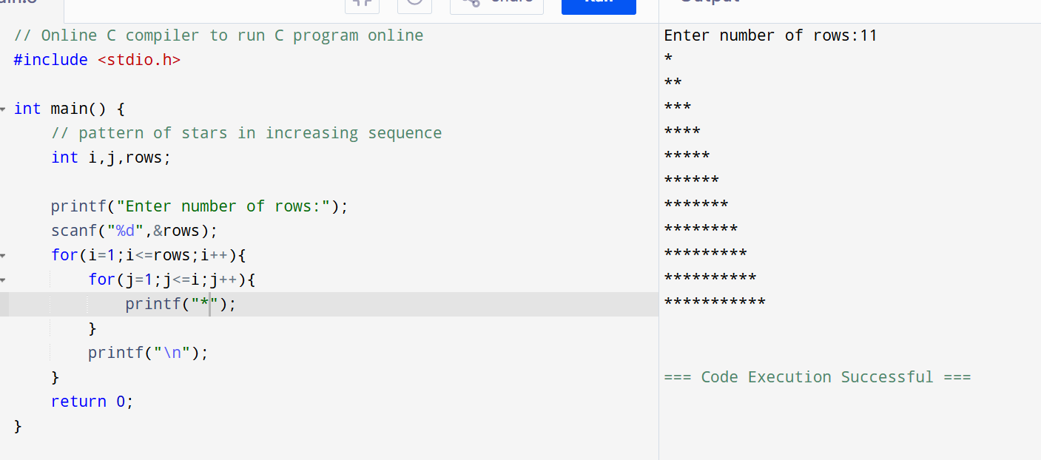

1. Program to find roots of quadratic equation

13.Program to generate Fibonacci Series.

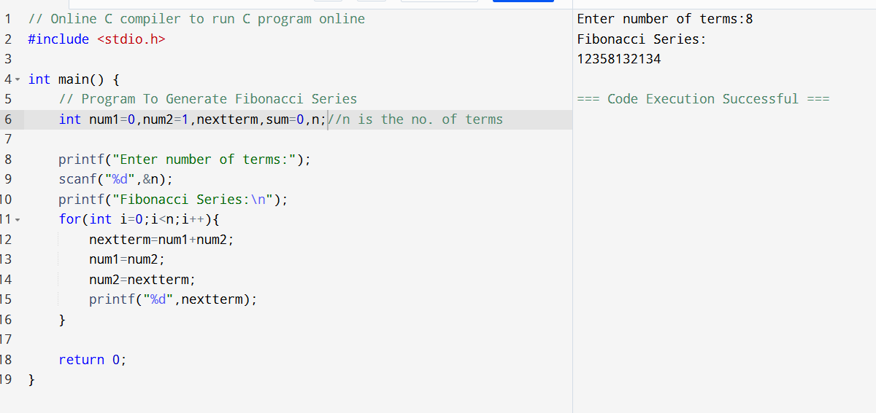

14.Program for Palindrome.

15. Program for Sum & Reverse of a 3-digit number.

16. Program for Armstrong

17.Program for Switching Monday to Sunday.

